Section 8.1

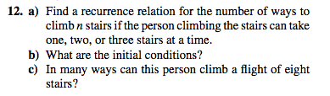

Section 8 p. 525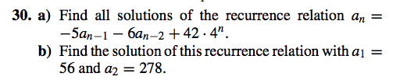

Section 10.2 p. 667

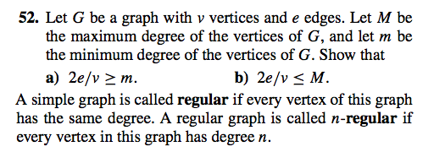

p. 668

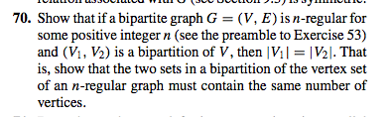

Section 10.3 p.677Macintosh HD:Users:jsjs:Desktop:Screen Shot 2014-04-01 at 9.52.08 AM.png

Section 10.5 p.706

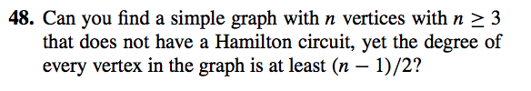

Section 10.7 p.726

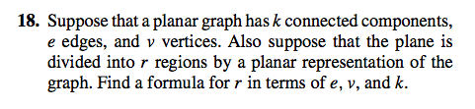

Section 10.8 p, 733

